# Azure Scenario 4:

Storing app data in cosmos db and using logic app to parse json data and process it.

## **STEPS:**

* Created Cosmos db named “**studententry”**.

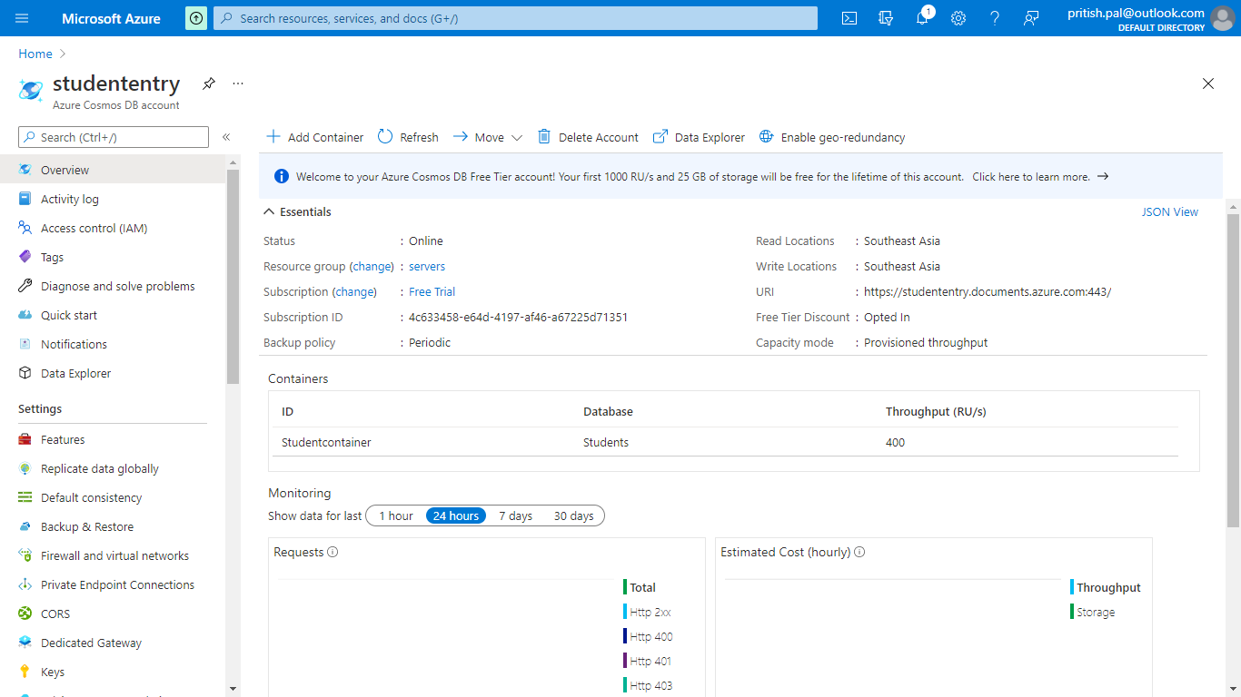

* Created database “**Students”** and container “**StudentContainer”, “MarksContainer”** via code. Also created a web application to register student entry via student class and marks entry via marks class.

**CosmosDBConnection class: for connection to cosmos DB**

using Microsoft.Azure.Cosmos;

using System;

using System.Collections.Generic;

using System.Linq;

using System.Threading.Tasks;

using System.Web;

namespace StuudentEntry.Models

{

public class CosmosDBConnection

{

private string EndpointUrl = Environment.GetEnvironmentVariable("EndpointUrl");

private string PrimaryKey = Environment.GetEnvironmentVariable("PrimaryKey");

private CosmosClient cosmosClient;

private Database database;

private Container container;

private string databaseId = "Students";

private string containerId = "Studentcontainer";

private async Task CreateDatabaseAsync()

{

this.database = await this.cosmosClient.CreateDatabaseIfNotExistsAsync(databaseId);

}

private async Task CreateContainerAsync()

{

this.container = await this.database.CreateContainerIfNotExistsAsync(containerId, "/Name");

}

private async Task AddItemsToContainerAsync(Student s)

{

ItemResponse<Student> studentadd = await this.container.CreateItemAsync<Student>(s, new PartitionKey(s.Name));

}

public async Task GetStartedDemoAsync(Student student, String url,string key)

{

this.cosmosClient = new CosmosClient(url, key);

await this.CreateDatabaseAsync();

await this.CreateContainerAsync();

await this.AddItemsToContainerAsync(student);

//await this.QueryItemsAsync();

}

}

}

**Students class:**

using Newtonsoft.Json;

using System;

using System.Collections.Generic;

using System.Linq;

using System.Web;

namespace StuudentEntry.Models

{

public class Student

{

[JsonProperty(PropertyName = "id")]

public string Id { get; set; }

public string Name { get; set; }

public string Status { get; set; }

}

}

**Marks class:**

using Newtonsoft.Json;

using System;

using System.Collections.Generic;

using System.Linq;

using System.Web;

namespace StuudentEntry.Models

{

public class Marks

{

[JsonProperty(PropertyName = "id")]

public string Id { get; set; }

public string marks1 { get; set; }

public string marks2 { get; set; }

public string marks3 { get; set; }

public string percent { get; set; }

}

}

**StudentController class:**

using System;

using System.Collections.Generic;

using System.Configuration;

using System.Data;

using System.Data.SqlClient;

using System.Linq;

using System.Web;

using System.Web.Mvc;

using System.Threading.Tasks;

using System.Net;

using Microsoft.Azure.Cosmos;

using StuudentEntry.Models;

using Newtonsoft.Json;

namespace StuudentEntry.Controllers

{

public class StudentController : Controller

{

public string EndpointUrl = "https://studententry.documents.azure.com:443/";

/// The primary key for the Azure DocumentDB account.

public string PrimaryKey = "yKZkUFZylIA7Z44PO2eMKj9G54CqdtZjNAFRYSrFk60lEibmB3OhjaNSrwiEtha4OXH0tmq8tWNEBhqeaRoxDw==";

// GET: Student

//public ActionResult Index()

//{

// return View();

//}

[HttpGet]

public ActionResult Register()

{

return View();

}

[HttpPost]

public async Task<string> Register(Student s)

{

//SqlConnection sqlConnection = new SqlConnection();

//string connectionString = ConfigurationManager.ConnectionStrings["conn"].ConnectionString;

//SqlCommand sqlCommand = new SqlCommand();

//sqlConnection.ConnectionString = connectionString;

//sqlCommand.CommandType = CommandType.Text;

//sqlCommand.CommandText = "insert into student values ("+s.Id+','+"'"+s.Name+"'"+","+"'"+s.Status+"'"+")";

//sqlCommand.Connection = sqlConnection;

//sqlConnection.Open();

//sqlCommand.ExecuteNonQuery();

//sqlConnection.Close();

CosmosDBConnection dbconn = new CosmosDBConnection();

await dbconn.GetStartedDemoAsync(s,EndpointUrl,PrimaryKey);

return "Student Registered successfully";

}

[HttpGet]

public ActionResult RegisterMarks()

{

return View();

}

[HttpPost]

public async Task<ActionResult> RegisterMarks(Marks s)

{

double student_percent;

int average_marks;

int marks1= (int)Convert.ToInt64(s.marks1);

int marks2= (int)Convert.ToInt64(s.marks2);

int marks3 = (int)Convert.ToInt64(s.marks3);

average_marks = marks1 + marks2 + marks3;

student_percent = average_marks*100/300;

string finalpercent= Convert.ToString(student_percent);

s.percent = finalpercent;

CosmosDBConnection dbconn = new CosmosDBConnection();

await dbconn.MarksAdder(EndpointUrl, PrimaryKey, s);

//SqlConnection sqlConnection = new SqlConnection();

//string connectionString = ConfigurationManager.ConnectionStrings["conn"].ConnectionString;

//SqlCommand sqlCommand = new SqlCommand();

//sqlConnection.ConnectionString = connectionString;

//sqlCommand.CommandType = CommandType.Text;

//sqlCommand.CommandText = "insert into marks values (" + s.Id + ',' + student_percent + ")";

//sqlCommand.Connection = sqlConnection;

//sqlConnection.Open();

//sqlCommand.ExecuteNonQuery();

//sqlConnection.Close();

return View();

}

}

}

Student data

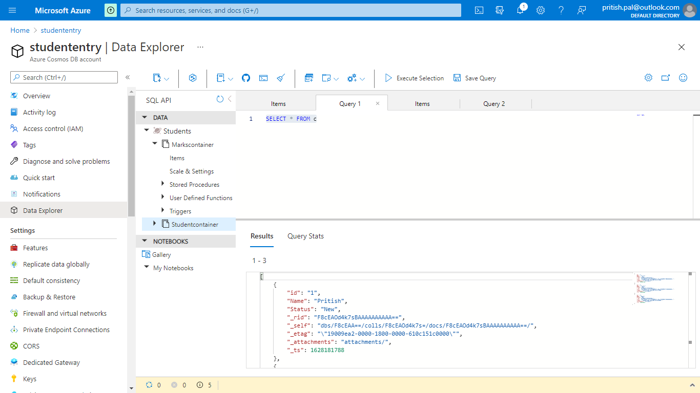

Marks data:

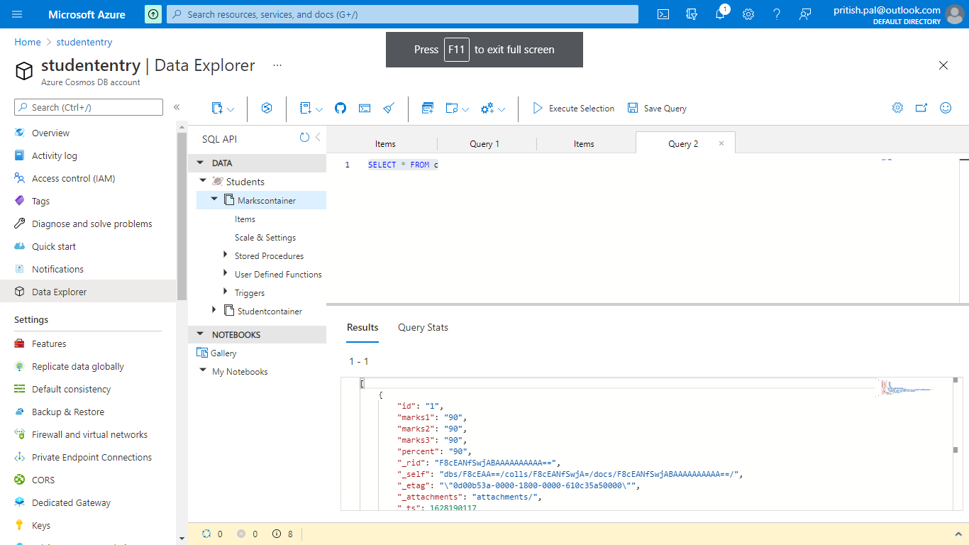

**References:**

https://soltisweb.com/blog/detail/2020-28-28-updating-cosmos-db-documents-with-azure-logic-apps